Matching Heads and Tails

Example from Geography

Before class
- Prepare the subject-related diagram/picture and sentence halves.
In class
- Pair off your learners. Give the following instructions. Hand out the worksheet.

Match the heads and tails below with the help of the following map. (Blue dots are cold deserts and the orange ones hot deserts.)
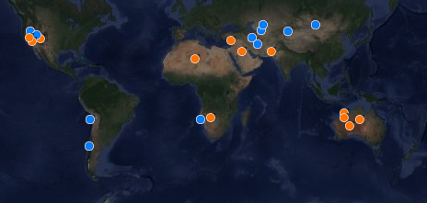
How many of the deserts marked on the map can you name?
How are deserts formed?
HEADS | TAILS
Some deserts form because they are 1 | two air dry masses meet and form stable conditions.
Other deserts form because they are | at either side of the equator.
Cold deserts form | dry places where little rain or snow falls.
Hot deserts form | in the rain shadow of large mountain ranges.1
Deserts are | a long way from the ocean and moist clouds cannot reach them.
Deserts form between oceans and mountains because | at higher latitudes.

