Labelling

Example from Biology: A cell

cytoplasm cell wall organelles nucleus chloroplast mitochondrion ribosomes
golgi apparatus vesicles vacuoles lysosomes nucleolus cytoskeleton

There are 3 terms too many.

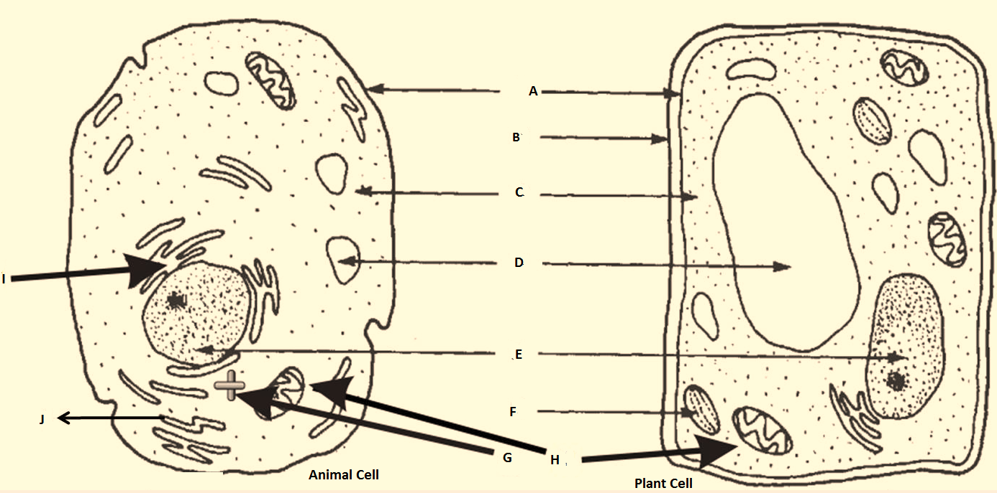
Source: Adapted from https://www.bing.com/images/

A E I
B F J
C G
D H

