Writing Frames

Example 1 from Science

Experiment procedure
Describe the procedure by using words from the list below.
water petri dish beaker Bunsen burner gauze tripod
liquid/cold/solid culture medium to mix to heat

1. First fill …
2. Then…
3. …
(Alternatively, add a diagram of the experiment sequence to help your learners.)

Example 2 from Science
Experiment report
We wanted to…
We used…
First we…
Then we…
After that we…
Finally we…
We thought ……… would be…
We learned that …

Finish these sentences.

Example 3 from Science

Write about air pollution. Finish the sentences.
Causes
These words will help you.
coal oil
natural gas burning
lung cancer ozone odourless colourless
diesel engine poisonous
…
Pollution is caused by…
Pollutants
The main pollutants are…
They are produced by…
Consequences
Polluted air can cause…
It also leads to…
It irritates…

Example 4 from Physics

A substitution table
Word list
focal length f focus F angle of view optical distance focal plane
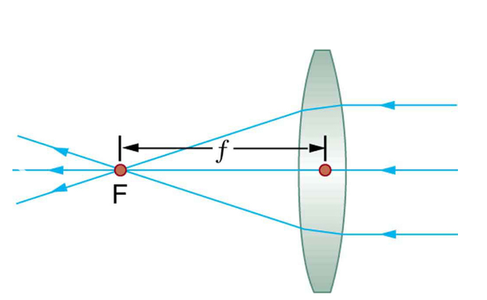
Sentence parts
If the ____________
smaller than
larger than
as large as
IS
,
the__________________

picture.
real
virtual
upright
inverted
reduced
________________
then the result is a

Write meaningful sentences.

